**SSN College of Engineering, Kalavakkam**

**Department of Computer Science and Engineering**

**III Semester - CSE**

# UCS 1312 Data Structures Lab Laboratory

|  |  |
| --- | --- |
| **Academic Year: 2021-2022** | **Batch: 2020-2024** |
| **Date of Assignment: 30.11.2021** | |

**Exercise 9: Graph Traversal and its Applications**

cityADT consists of adjacency matrix that represents the connection between the cities. Adjacency matrix has an entry 1, if there is a connection between the cities. Implement the following methods.

* void create(cityADT *C) – will create the graph using adjacency matrix
* void disp(cityADT *C) – display the adjacency matrix
* void BFS(cityADT *C) – provides the output of visiting the cities by following

breadth first

* void DFS(cityADT *C) – provides the output of visiting the cities by following

depth first

1. Demonstrate the ADT with the following testcase

For the following Graph,

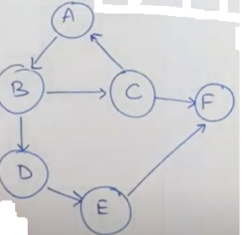

Enter the no. of vertices: 6

Enter the no. of edges: 7

AB, BC, BD, CA, CF, DE, EF

Adjacency Matrix

|  |  |  |  |  |  |  |
| --- | --- | --- | --- | --- | --- | --- |
|  | A | B | C | D | E | F |
| A | 0 | 1 | 0 | 0 | 0 | 0 |
| B | 0 | 0 | 1 | 1 | 0 | 0 |
| C | 1 | 0 | 0 | 0 | 0 | 1 |
| D | 0 | 0 | 0 | 0 | 1 | 0 |
| E | 0 | 0 | 0 | 0 | 0 | 1 |
| F | 0 | 0 | 0 | 0 | 0 | 0 |

BFS Output: ABCDFE for Start vertex A

DFS Output: ABCDFE for Start vertex A

2. Write an application to utilize traversals to do the following:

1. Given the source and destination cities, find whether there is a path from source to destination
2. Find the connected components in a given graph

Test the application with the following

Input:

Source: D

Destination: F

Output:

Path exists

Input:

Source: F

Destination: B

Output:

Path not exists

Input:

